Activity diagram 1. UC 1.1-2.1-1.5

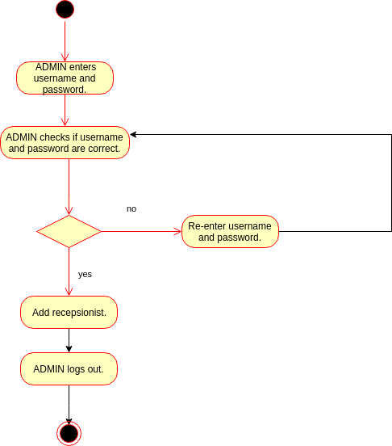

Activity diagram 2. UC 1.1-2.1-1.5

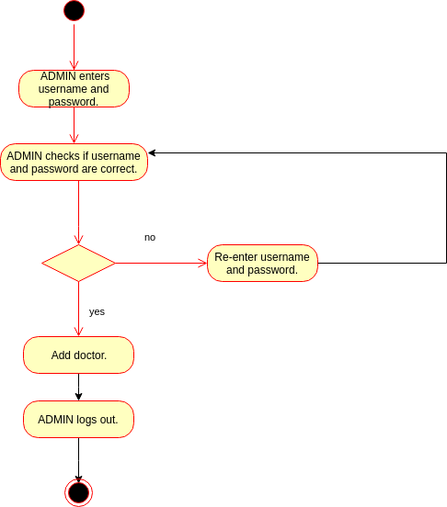

Activity diagram 3. UC 1.1-2.1-1.5

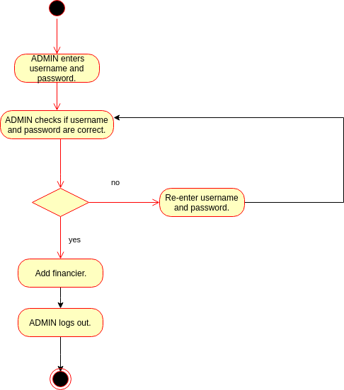

Activity diagram 4. UC 1.1-2.2-1.5

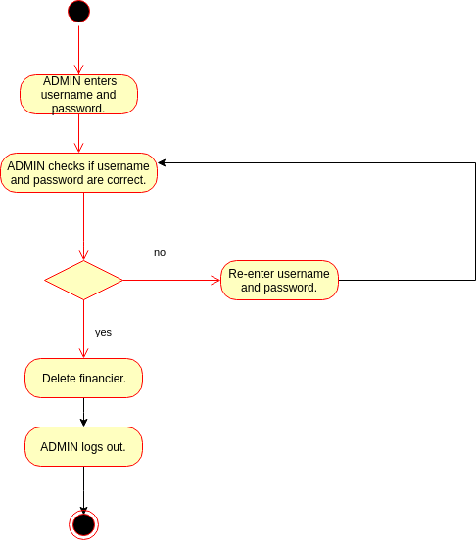

Activity diagram 5. UC 1.1-2.2-1.5

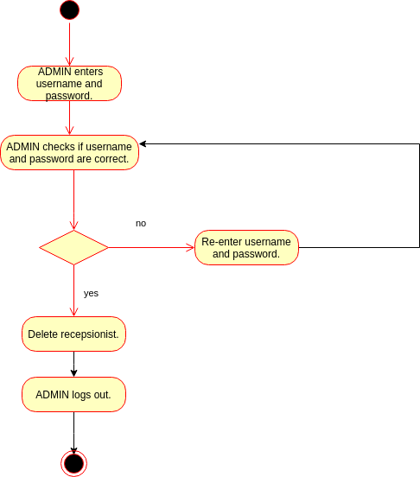

Activity diagram 6. UC 1.1-2.2-1.5

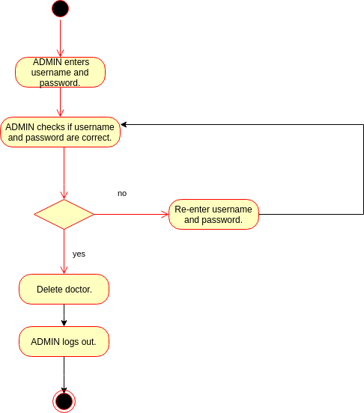

Activity diagram 7. UC 1.1-2.4-1.4-1.5

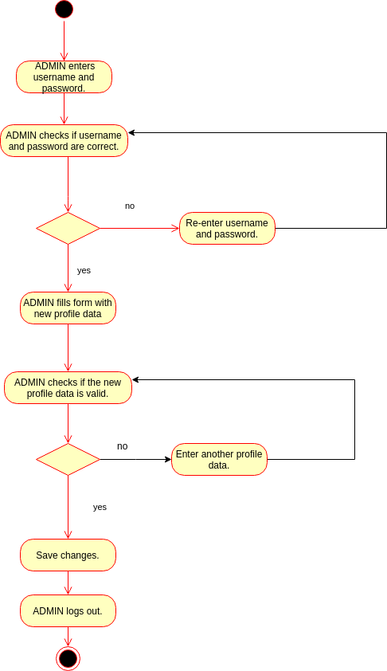

Activity diagram 8. UC 1.1-2.3

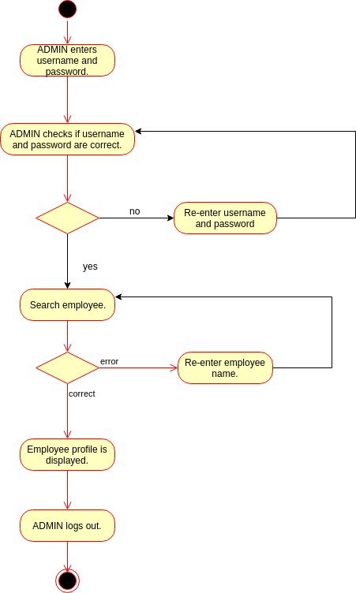

Activity diagram 9. UC 1.1-1.3-1.5

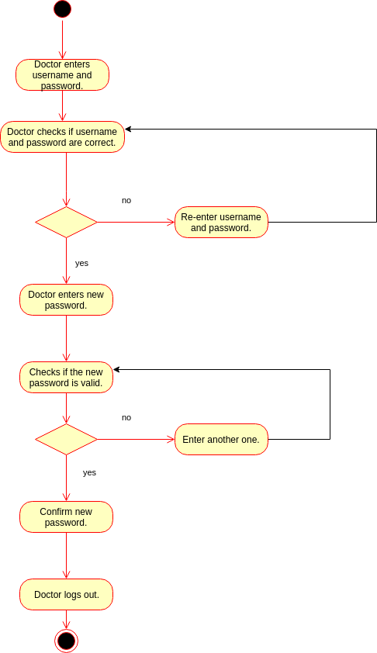

Activity diagram 10. UC 1.1-1.3-1.5

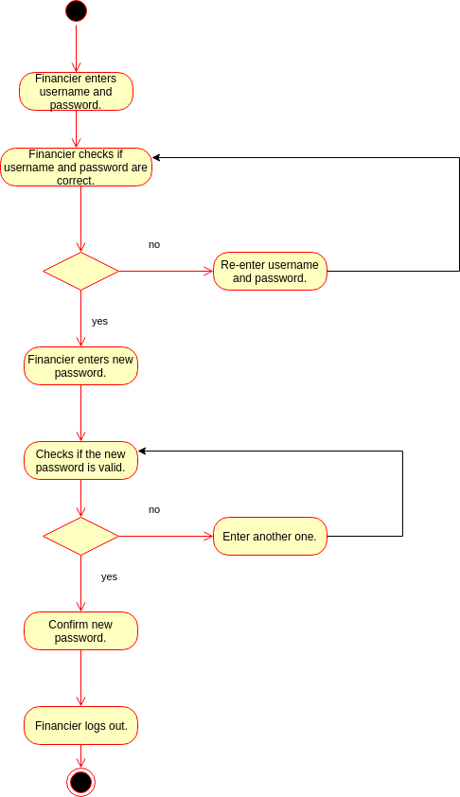

Activity diagram 11. UC 1.1-1.3-1.5

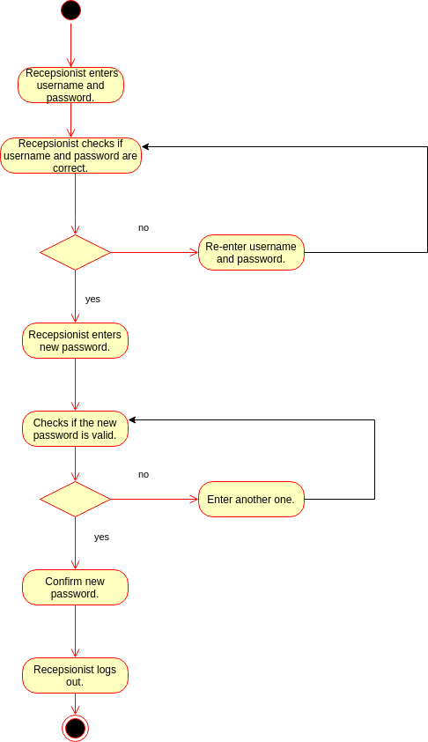

Activity diagram 12. UC 1.1-3.1-3.2-1.5

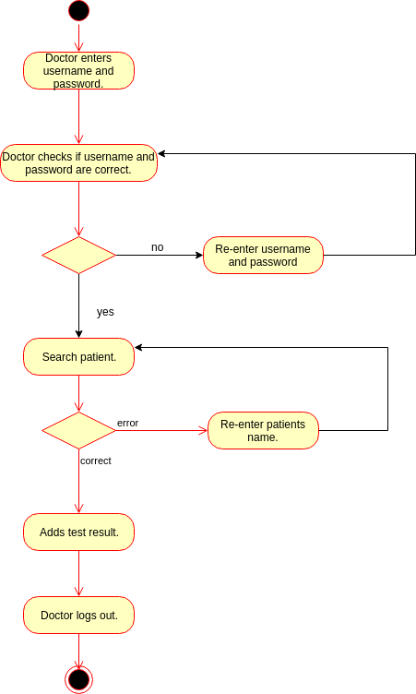

Activity diagram 13. UC 1. 1-4.1-4.4-1.5

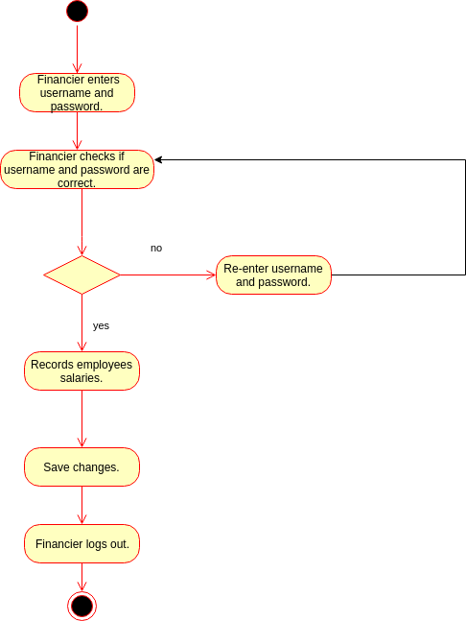

Activity diagram 14. UC 1.1-4.2-4.4-1.5

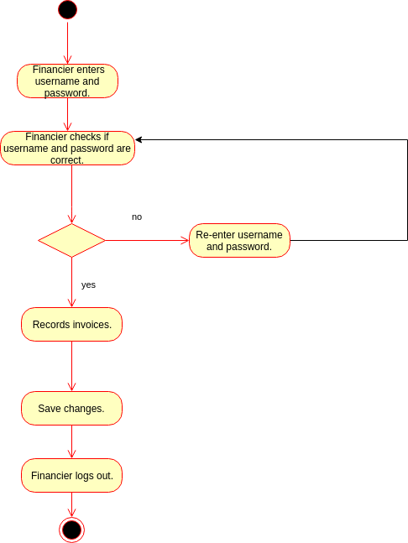

Activity diagram 15. UC 1.1-4.3-4.4-1.5

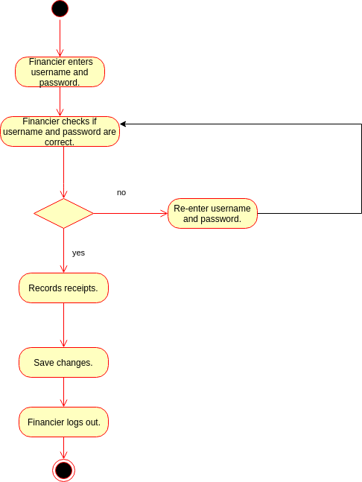

Activity diagram 16. UC 1.1-5.1-5.2-5.3-5.4

